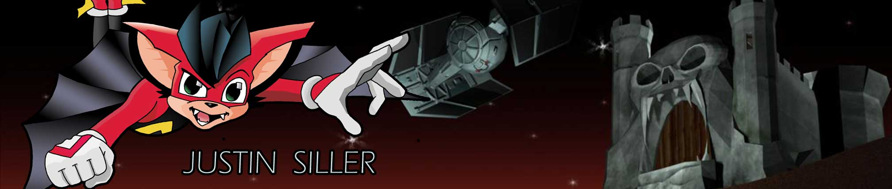
E-MAIL JDSILLER@yahoo.com website: www.justinsiller.com

Designer, Artist – Video games and cartoon intellectual property

SUMMARY OF QUALIFICATIONS

Production roles on six shipped titles as designer, artist, and/or producer and support roles on four shipped titles.
- Traditional illustration skills with emphasis on character design and map layouts.
- 3D art skills with emphasis in polygonal (Maya) and CSG modeling of backgrounds and level assets, texture design, and shaders.
- Professional experience in level design, layout, and creation including path editing, triggers, and entity placement.
- Professional experience writing game design documents, story, and dialogue.

EXPERIENCE

Sony Computer Entertainment of America
QA and Online Support (contract through Nelson Staffing) 5/2005-9/2005

Moderator and support duties for all first-party online titles.

Sony Online Entertainment
Product testing analyst (contract through Mentor 4, Inc.) 12/2004 –2/2005

Untold Legends: Brotherhood of the Blade – Sony PSP (shipped 2005)

Midway Home Entertainment
Product testing analyst (contract through Appleone, Inc.) 6/2004 – 11/2004

Mortal Kombat: Deception – Sony Playstation 2 (shipped 2004)

Dragonstone Software
Lead Designer / Lead Level Artist 5/99 – 3/2001

Dragon’s Lair 3D – PC and XBOX (shipped 2002)
- Wrote game cinemas and created concept art for new game characters.
- Initially worked to create the original design document and lead design meetings. Later functioned as lead level designer training junior level designers.
- Blocked out world space in Tread 3D (CSG) and divided by section for assignment to individual designers.
- Created final geometry and lighting for individual rooms/ areas including, but not limited to: Castle entrance, Main Hall, Hall of Skulls, and Singe’s Lair.
- Modeled various prefabs and elements.
- Designed and applied textures.
- Managed the tracking of all level assets in SourceSafe.
- Offered assistance and suggestions in the development of Tread 3D which were implemented.

Player 1, Inc.
Associate Producer/ Designer 11/97 – 8/98

Tommy Thunder – Sony Playstation (1998)
- Managed scope reduction and redesign of Tommy Thunder, an original in-house design.
- Designed level maps and game flow.
- Acted as liaison between management and creative team of designers, artists, and programmers.

Visual Concepts
Quality Assurance (Contract) 9/1997 – 11/97

ONE – Sony Playstation (shipped 1997)
- Laid out enemy paths and cameras.
- Worked with artists to balance difficulty and flow of the game.
- Managed internal and external QA efforts and managed prioritization of bugs.

Disney Interactive
Associate Producer/ Designer 9/96 – 4/97

Hercules On-line Adventure – Sony Playstation (1997)
- Managed internal design efforts and trained junior designers on Hercules On-line Adventure, a proposed project for PC platform.
- Managed external developer and researched technical considerations.
- Designed charts for character abilities, attacks, and special moves.

S’punj
- Assisted in story creation and writing game design documents.
- Acted as associate designer.

Interplay Productions
Associate Producer/ Designer 12/94 – 3/96

Casper – 3DO, Sony Playstation, and Sega Saturn (shipped 1996)

Producer on project developed in Norway.

Managed procurement of audio assets, dev kits, licenses, and milestone schedules.

Spent three weeks on-site overseas to act as liaison between publisher and developer.
- Worked with legal department to secure contracts with licensees.
- Ran the 3DO development kit internally at Interplay for all code updates.

Earthworm Jim: Special Edition – Sega CD (shipped 1995)
- Produced title for publishing by Interplay.
- Managed coordination of development with internal marketing and QA.
- Game received Editor’s Choice Gold Award in the industry publication EGM.

Boogerman - SNES (shipped 1995)
- Managed internal QA efforts for port over to SNES.

Sunsoft of America

Associate Producer/ Designer 3/93 – 8/94

Zero the Kamikaze Squirrel – Nintendo SNES and Sega Genesis (shipped 1994)
- Creator and Main Character designer.
- Designed main player mechanics, enemies, and general game flow.
- Wrote story, dialogue and storyboarded cinematics.

Zero was featured in Disney Adventures magazine as one of the magazine’s favorite video game villains.
- Game received Editor’s Choice Gold Award in the industry publication EGM.

Aero the Acrobat 2 – Nintendo SNES and Sega Genesis (shipped 1994)
- Created character designs for enemies and circus train.
- Associate producer on the title.

Aero the Acrobat – Nintendo SNES and Sega Genesis (shipped 1993)
- Co-creator of the intellectual property.
- Designed the original and establishing looks for title character and his arch nemesis.
- Designed the E3 promotional pin.

TECHNICAL SKILLS

Writing/ Design All story and game elements. Design documents, level layouts.
Illustration Traditional character design.
3D Modeling CSG game editors and Maya.
Textures Using Photoshop.
Shader networks Using Maya.

EDUCATION
1993 – 1995 California State University, Long Beach Film Studies
1991 – 1993 California State University, Northridge Graphic Design

INTERESTS/ HOBBIES

Platform, Stealth Action, and Extreme sport console games.
RTS and FPS computer games.
Any games that are balanced and fun regardless of genre.
Magic: The Gathering
Comic book illustration. (Original IPs currently in development)

